<https://www.artstation.com/artwork/EawgdN>

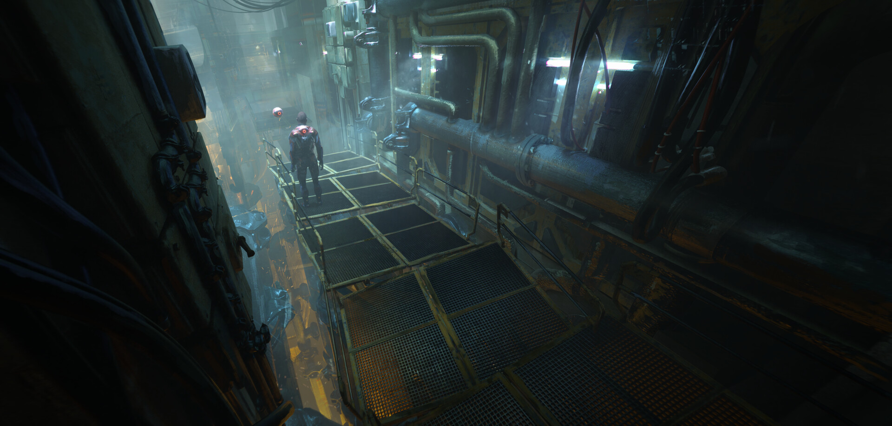

<https://www.artstation.com/artwork/w89P05>

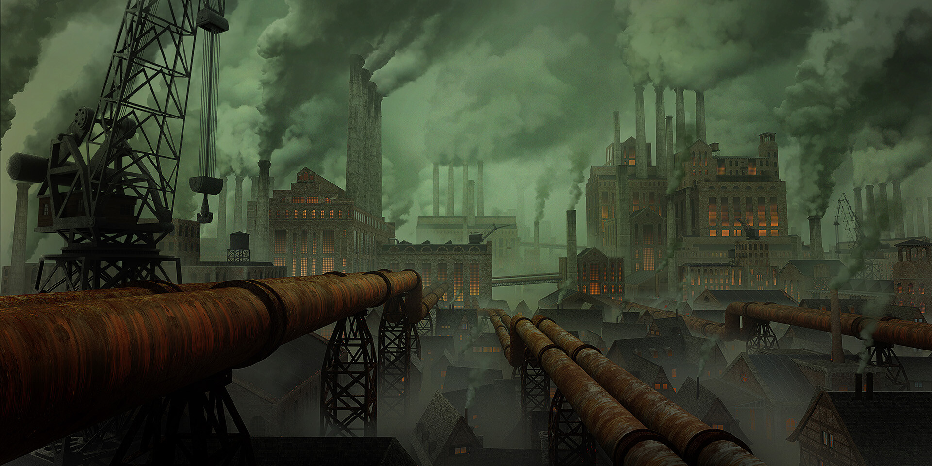

<https://www.artstation.com/artwork/w89P05>

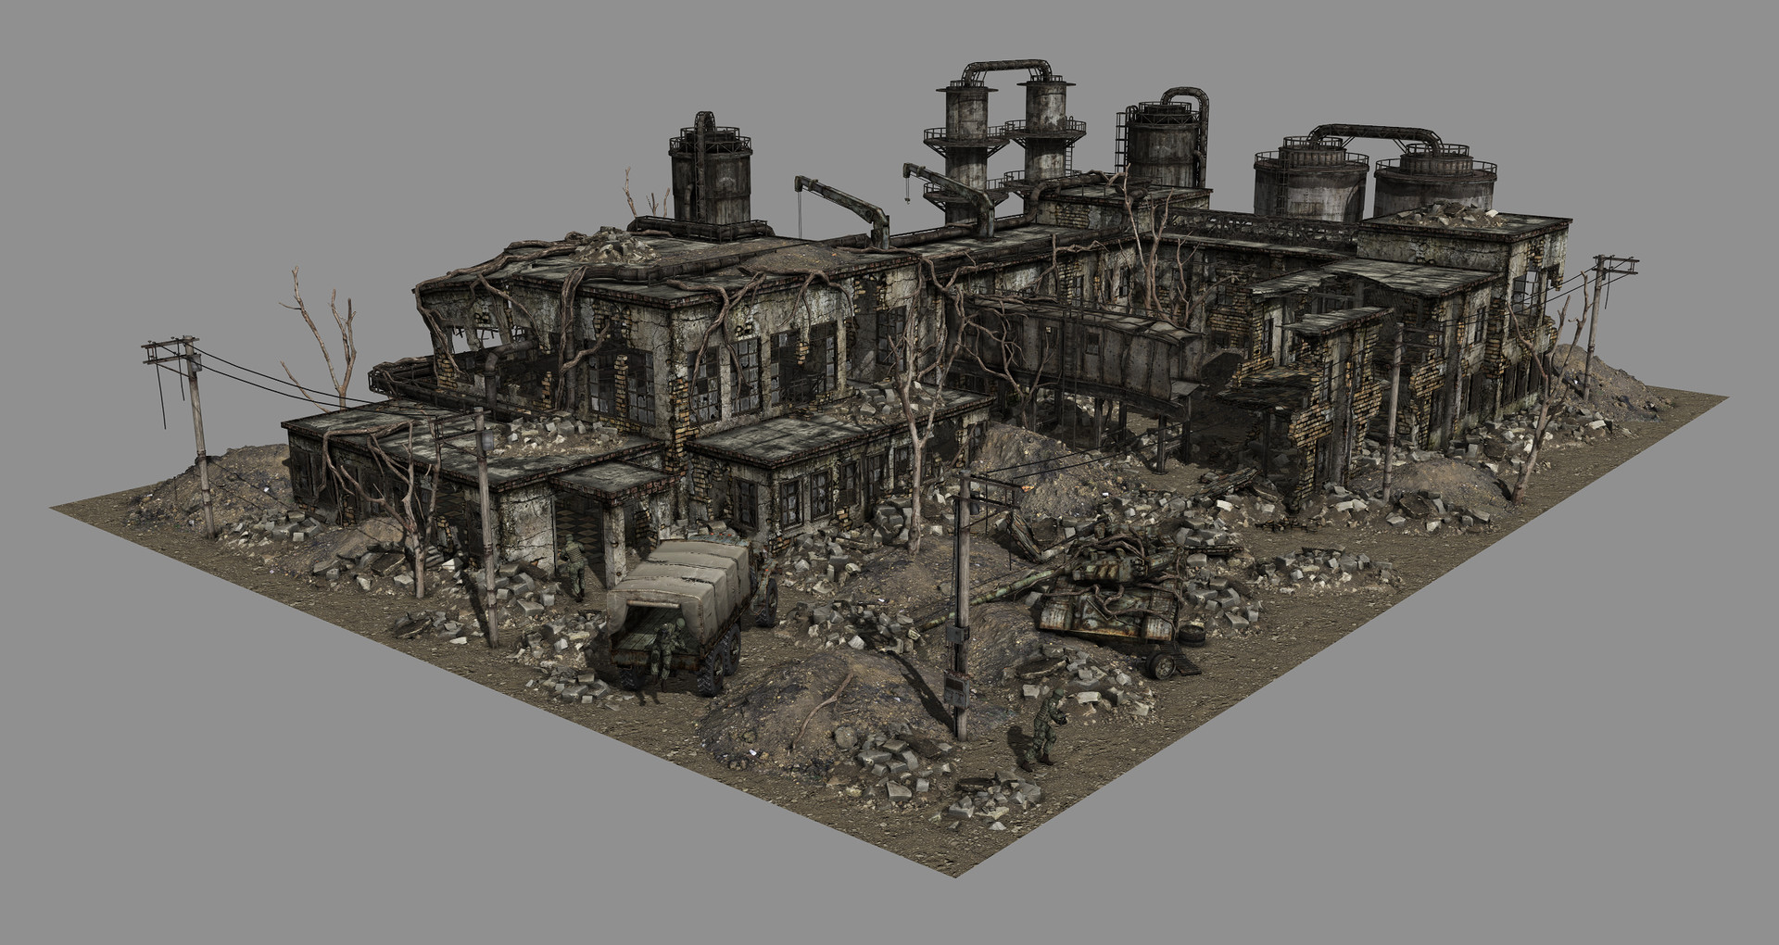

<https://www.artstation.com/artwork/PeqyA8>

